Learn the basic networking terms

- IP Address: An IP address is a unique numerical address used to identify a device on a network. For example, 192.168.1.10.

- Router: A router connects different networks and forwards data between your computer and the internet.

- Server: A server is a computer that provides services or resources, such as website pages, to other computers.

- Client: A client is a device or application that requests services from a server. For example, your web browser is a client.

- DNS (Domain Name System): DNS translates website names, such as google.com, into IP addresses that computers use to find servers.

What happens when you type a website address into your browser?
Suppose you type www.example.com into your browser.
- You enter the website address. Your browser receives the domain name.
- DNS finds the IP address. Your computer checks its cache or contacts a DNS resolver to find the website server's IP address.
- Your computer sends a request. The request travels through your router and your internet service provider (ISP) toward the server.
- A connection is established. For an HTTPS website, your browser establishes a secure connection with the server.
- The server responds. The server sends website data, such as HTML, CSS, JavaScript, and images, back to your browser.
- The website appears. Your browser processes the received data and displays the webpage.

Draw a simple diagram showing your computer, a router, the internet, and a website server.

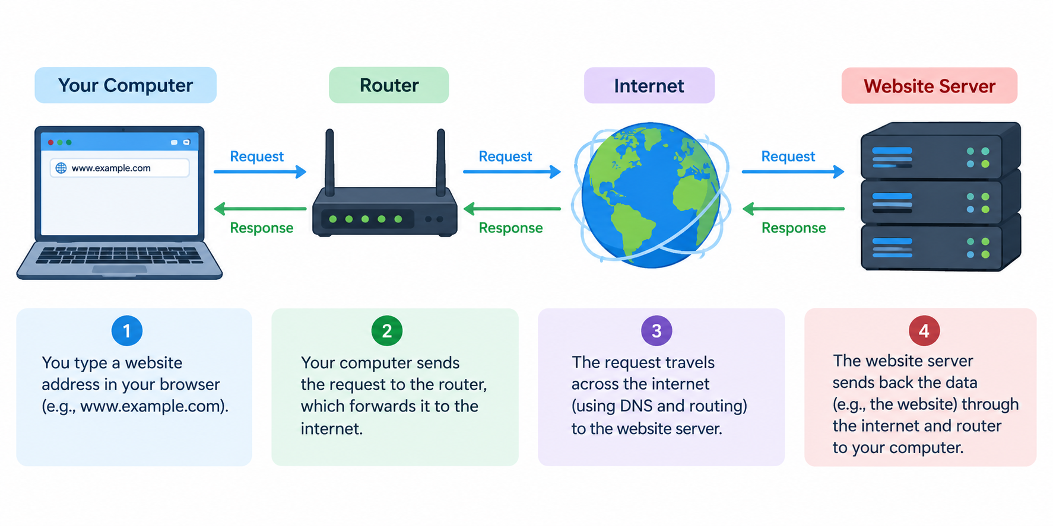
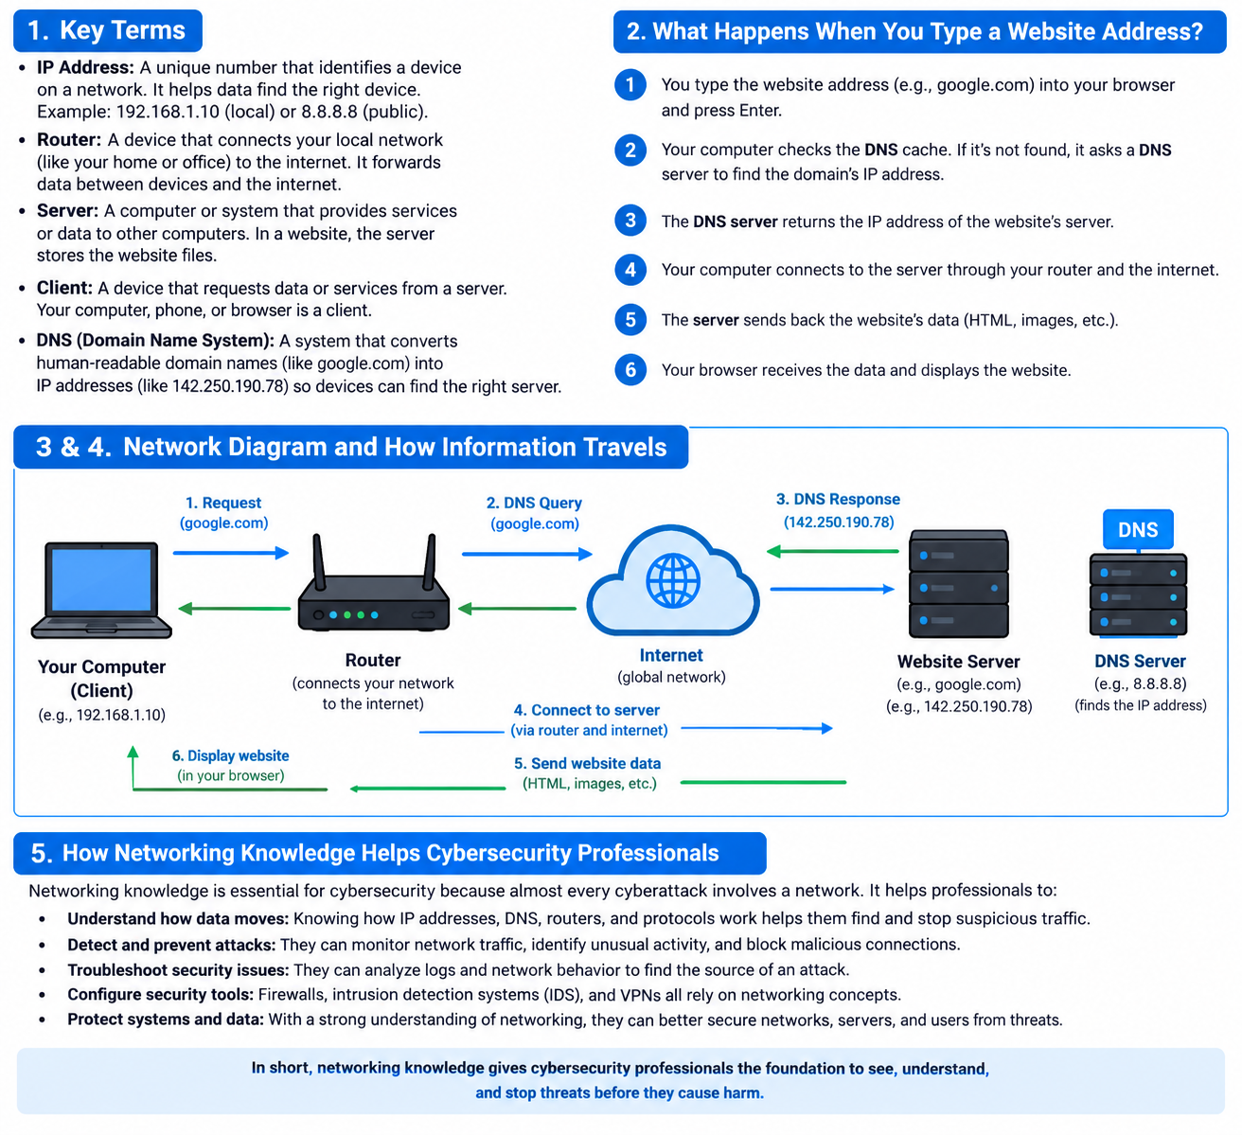
Write a short explanation of how networking knowledge helps cybersecurity professionals.
Networking knowledge helps cybersecurity professionals understand how computers communicate and how data travels across networks. It helps them identify security vulnerabilities, detect suspicious traffic, prevent unauthorized access, and protect systems from cyberattacks. Knowledge of IP addresses, DNS, routers, ports, and protocols allows them to monitor network activity, investigate threats, and secure computer systems.

